TEAM ID:PNT2022TMID35083

Develop The Web Application Using Node-RED

Develop the web application using Node-RED

The web application should have the following features:

* Connect to the IBM IoT platform and get the location data
* Display the location on a Google map
* Check whether the child is inside the geofence or not
* Send the notification if the child goes out of the geofence
* Store all the location data in the cloudant DB

Connect to IBM IoT platform and get the location, store the data in cloudant DB.

Integrate the geofence to check if the child is inside or outside the geofence and display the location in Google Maps.

Send the notification if the child is out of geofence.

We should need dashboard nodes to be installed to build a dashboard.We followed the below steps to install

1. When we open our node-RED flow it looks like the image below

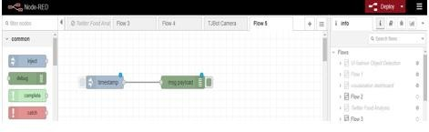

1. We clicked on the drop-down list and selected the manage palette as shown below

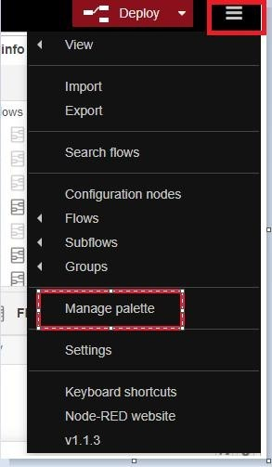

1. In the manage Palette search for "node-red-dashboard" and installed it.
2. Also, we need geofence nodes for creating a geofence. to install it search for "node-rednode-geofence" in the manage palette and install them.

We need world map nodes for displaying the location in the world map. Search for "node-red-contrib-web-worldmap" in the manage palette and install them.